In the context of Support Vector Machines (SVM), there are three important concepts: the hyperplane, support vectors, and the margin. Let's differentiate between them:

1. **Hyperplane**:
   * The hyperplane is the decision boundary that separates data points of different classes in a binary classification problem.
   * In a two-dimensional feature space, it's a line; in higher-dimensional spaces, it's a flat affine subspace.
   * Mathematically, a hyperplane is represented as **w * x + b = 0**, where:
     + "w" is the weight vector, which is perpendicular to the hyperplane.
     + "x" is a data point.
     + "b" is the bias or intercept term.
2. **Support Vectors**:
   * Support vectors are the data points that are closest to the hyperplane and play a crucial role in defining the margin.
   * These are the data points that have the smallest margin or the ones that lie on or inside the margin boundaries.
   * Support vectors are the most challenging data points for the SVM; they have a non-zero weight in determining the position of the hyperplane.
   * They are the only data points that matter in defining the hyperplane and the margin.
3. **Margin**:
   * The margin is the separation or gap between the decision boundary (hyperplane) and the nearest support vectors from each class.
   * It is a scalar value that quantifies how well-separated the classes are in the feature space.
   * A larger margin implies better separation between classes and is generally associated with better generalization performance.
   * The margin is calculated as the perpendicular distance from the hyperplane to the nearest support vectors.

In summary, the hyperplane is the decision boundary that separates classes, support vectors are the closest data points to the hyperplane, and the margin is the distance between the hyperplane and these support vectors. SVM aims to find the hyperplane that maximizes this margin, as it's a critical factor in determining the classifier's performance and robustness.

Top of Form

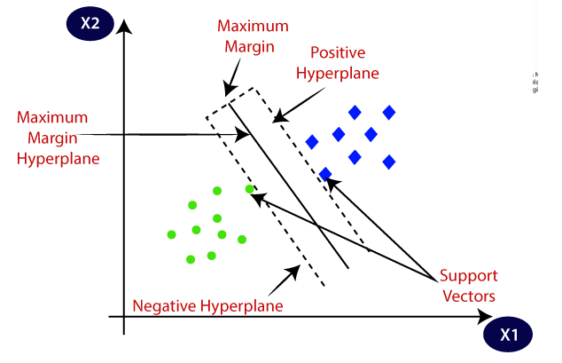

1. **Mathematical Representation of the Hyperplane:**
   * The hyperplane is represented as the equation: **w * x + b = 0**
     + "w" is the weight vector perpendicular to the hyperplane.
     + "x" is a data point in the feature space.
     + "b" is the bias or intercept term.
   * The hyperplane is the decision boundary that separates data points. Points on one side of the hyperplane belong to one class, and points on the other side belong to the other class.
2. **Mathematical Representation of the Margin:**
   * The margin is mathematically calculated as: **M = 2 / ||w||**
     + "M" represents the margin.
     + "||w||" represents the Euclidean norm (magnitude) of the weight vector "w."
   * The margin quantifies the distance between the hyperplane and the nearest data points from each class in the feature space.
   * A larger margin implies better separation between classes and better generalization performance.

once hyperplane create like 0.5*x1-0.5X2+2 then what is role of margin here

The equation of a hyperplane, such as the one you provided, plays a crucial role in defining the decision boundary in a Support Vector Machine (SVM). In the equation:

0.5 * X1 - 0.5 * X2 + 2 = 0

* "0.5 * X1" and "-0.5 * X2" are the coefficients of the features X1 and X2 in the weight vector w.
* "2" is the bias term b.

This equation defines a decision boundary in the feature space. Data points that satisfy this equation (i.e., 0.5 * X1 - 0.5 * X2 + 2 = 0) lie on the decision boundary itself.

The margin, in the context of SVMs, is the distance between the decision boundary (hyperplane) and the nearest data point (support vector) from either class. The margin is determined by the weight vector w.

The role of the margin here is to provide a measure of the separation between the classes. A larger margin indicates a more confident separation, meaning that the SVM is less likely to make errors on new, unseen data. The margin also helps control overfitting, as it encourages the SVM to find a more generalized solution.

In practice, when classifying new data points, you evaluate the sign of the equation "0.5 * X1 - 0.5 * X2 + 2" for those points. If the result is positive, the data point is classified as one class, and if it's negative, it's classified as the other class. The margin, while not explicitly present in the equation, influences the confidence of this classification. Points closer to the decision boundary may be classified less confidently than those further away.

In summary, the margin, although not explicitly mentioned in the equation, is determined by the weight vector w and plays a critical role in the SVM's classification and generalization performance. It represents the separation between the classes and affects the confidence of class assignments.

confidence of class assignments. with an example

Confidence in class assignments in a Support Vector Machine (SVM) is related to how far a data point is from the decision boundary (hyperplane). Points further from the hyperplane are classified with higher confidence, while points closer to the boundary are classified with lower confidence. This is because the margin, which is the distance between the hyperplane and the nearest data point, influences the confidence level.

Let's consider an example with a simplified linear SVM model and two classes, Class A and Class B, using a 2D feature space (X1, X2). Our hyperplane equation is:

0.5 * X1 - 0.5 * X2 + 2 = 0

In this equation, data points are classified based on the sign of "0.5 * X1 - 0.5 * X2 + 2." Specifically:

* If "0.5 * X1 - 0.5 * X2 + 2" is positive, the data point is classified as Class A.
* If "0.5 * X1 - 0.5 * X2 + 2" is negative, the data point is classified as Class B.

Now, let's consider two new data points:

1. Data point P1 with features (X1 = 4, X2 = 3).
2. Data point P2 with features (X1 = 5, X2 = 6).

We can calculate the values of "0.5 * X1 - 0.5 * X2 + 2" for both points:

For P1: 0.5 * 4 - 0.5 * 3 + 2 = 2 + 1.5 + 2 = 5.5

For P2: 0.5 * 5 - 0.5 * 6 + 2 = 2.5 - 3 + 2 = 1.5

Now, let's interpret the results:

1. For P1, "0.5 * X1 - 0.5 * X2 + 2" is 5.5, which is a large positive value. This indicates that P1 is classified with high confidence as Class A because it's far from the decision boundary.
2. For P2, "0.5 * X1 - 0.5 * X2 + 2" is 1.5, which is a positive value but smaller than for P1. This suggests that P2 is classified as Class A but with slightly less confidence compared to P1 because it's closer to the decision boundary.

In this example, the values of "0.5 * X1 - 0.5 * X2 + 2" provide a measure of the confidence of the class assignments. Larger positive values indicate higher confidence in Class A, while smaller positive values indicate lower confidence. Similarly, negative values would indicate Class B with varying levels of confidence depending on the magnitude of the value.

how margin solves above

In the context of Support Vector Machines (SVMs), the margin is closely related to how data points are classified and how confidence in class assignments is determined. The margin defines the distance between the decision boundary (hyperplane) and the nearest data point from either class. This margin can be crucial in understanding and quantifying the confidence of class assignments.

Let's revisit your SVM hyperplane equation:

0.5 * X1 - 0.5 * X2 + 2 = 0

In this equation, the margin is inversely proportional to the Euclidean norm (magnitude) of the weight vector �*w*. The margin (M) can be calculated as:

�=2∥�∥*M*=∥*w*∥2​

So, the margin depends on the values of the coefficients (weights) in the weight vector �*w*. When the margin is larger, it means that the weight vector �*w* has smaller Euclidean norm, which in turn implies that data points are farther from the decision boundary (hyperplane). Larger margins indicate higher confidence in the class assignments because there is more separation between the classes.

To illustrate this with an example, consider two scenarios:

**Scenario 1**: If the SVM optimization problem finds a weight vector �*w* such that the margin is large (e.g., M = 5), it means that the decision boundary has a significant separation from the data points. Class assignments are made with high confidence because there is a wide gap between the decision boundary and the data.

**Scenario 2**: If the SVM optimization problem finds a weight vector �*w* such that the margin is small (e.g., M = 1), it means that the decision boundary is closer to the data points. Class assignments are made with lower confidence because the decision boundary is less robust to variations in the data.

In summary, the margin in SVMs plays a vital role in determining the confidence of class assignments. A larger margin indicates higher confidence, while a smaller margin indicates lower confidence. The margin quantifies the separation between the classes and influences the model's generalization and robustness.

Top of Form